**Part 2: Designing Alternatives**

**Scenarios:**

**Scenario 1:** A high school student is finding it hard to focus on her homework and studying for exams. She often gets sidetracked by notifications from social media apps like Instagram and Snapchat. Despite setting goals to study for a certain number of hours each day, she ends up scrolling through her feeds for hours. Emma decides to use the app to help her reduce her screen time. By earning plants and building a virtual garden, she feels motivated to spend less time on her phone and more time on her studies. Over time, she notices an improvement in her grades and a significant reduction in her screen time.

**Scenario 2:** A college sophomore is preparing for his midterm exams but struggles with procrastination, particularly with mobile games. Every time he sits down to study, he gets distracted by game notifications and the temptation to play "just one more level." Realizing this is affecting his academic performance, James installs the app to help manage his phone usage. The app's feature of growing a virtual garden by staying off his phone appeals to him. He starts using the app regularly and finds that he's able to concentrate better on his studies. His productivity increases, and he feels more accomplished seeing his garden flourish.

**Scenario 3:** A postgraduate student is working on her thesis but constantly interrupts her work by checking messages and updates on social media. She recognizes that her phone usage is hindering her progress and decides to try the app to create a healthier balance. By setting specific times to be away from her phone and earning rewards in the form of plants, Lily can focus more effectively on her thesis work. The minimalistic design of the app ensures that it doesn't become another distraction. As she spends more time working on her thesis, she sees positive feedback from her advisor and makes significant strides towards completion.

**Storyboard (Based on Scenarios):**

**Scenario 1 - "Social Media Distraction"**

**Scenario 2 - "Gaming Temptation"**

**Scenario 3 - "Thesis Interruptions"**

**Problem Statement:**

* Students Excessive Use of Social Media
* Students are Addicted to Mobile Games
* Students Constant Interruptions from Notifications

**Application Icon Size Comparison**

**C:\Users\user\AppData\Local\Microsoft\Windows\INetCache\Content.Word\Time Garden Resize (48x48).png  **



**36x36 48x48 72x72 96x96**





**144x144 192x192**

The icons above showcase the application icon in various sizes. This is essential to identify how it would look in many different screen ratios.

**Design**

Time Garden aims for a comfortable, minimalist style. To achieve this design, the following will be identified: Color Palette, Font Style, and GUI.

**Color Palettes**

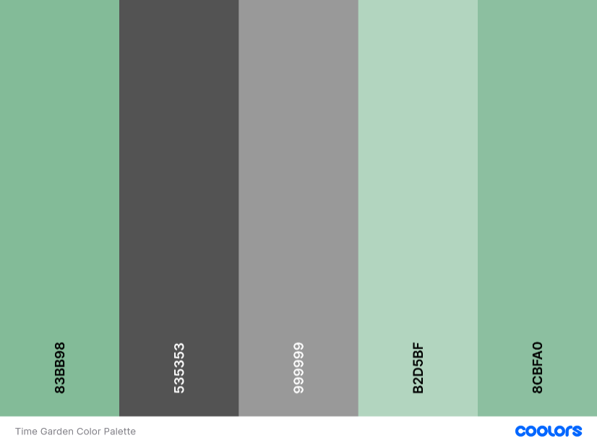

**Font Style**

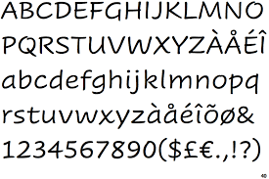

**Cavolini**

Because of the garden theme of Time Garden, we chose a font that invokes softer feel, with slightly less uniformity in favor of comfort.

**GUI**

The team has decided to use a mobile GUI for the application to keep it simple and not complicate the app any further by trying to adapt to other GUIs for different models. The team has created this mock-up/prototype using Figma.

(DESCRIPTION)

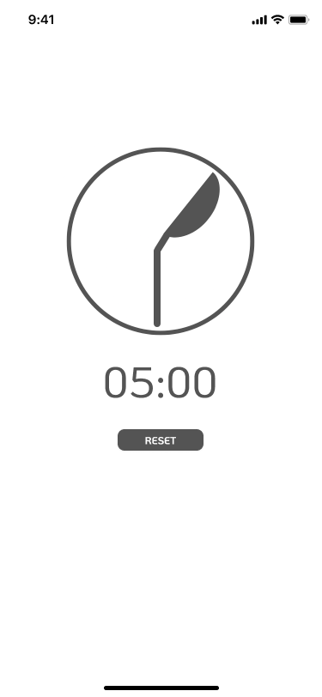

(Description)